**Single 2−input AND Gate**

###### General Description

The ETQ74LVC1G08 is a single 2−input AND Gate operating from a 1.65V to 5.5V supply. This device is fabricated with advanced CMOS technology to achieve ultra-high speed with high output drive.

###### Features

* Designed for 1.65V to 5.5V VCC Operation
* Over-voltage Tolerant Inputs
* 24mA Balanced Output Sink and Source Capability
* Near Zero Static Supply Current Substantially Reduces System Power Requirements
* These Devices are Pb−Free and are RoHS Compliant
* Multiple Package Options Automotive AEC-Q100 Grade 1 Qualified

-- Ambient Temperature Range of -40°C to +125°C

-- ESD HBM ±4KV PASS

-- ESD CDM ±1KV PASS

-- Latch Up Current to 100mA PASS

###### Ordering Information

|  |  |  |
| --- | --- | --- |
| **Part No.** | **Package** | **MSL** |
| ETQ74LVC1G08 | SC70-5(1.3mm×2.1mm) | 1 |

###### Pin Configuration



SC70-5

Figure1. Top View

###### Pin Function

SC70-5

|  |  |  |
| --- | --- | --- |
| **Pin No.** | **Pin Name** | **Function** |
| 1 | A | Input A |
| 2 | B | Input B |
| 3 | GND | Ground |
| 4 | Y | Output |
| 5 | VCC | Supply Voltage |

###### Block Diagram

|  |
| --- |
| Figure2. Logic Symbol |

###### Functional Description

Function Table

|  |  |  |
| --- | --- | --- |
| **Input** | | **Output** |
| **A** | **B** | **Y** |
| L | L | L |
| L | H | L |
| H | L | L |
| H | H | H |

###### Absolute Maximum Ratings

|  |  |  |  |  |
| --- | --- | --- | --- | --- |
| **Symbol** | **Parameter** | | **Value** | **Unit** |
| VCC | DC Supply Voltage | | -0.5 to 7.0 | V |
| VI | DC Input Voltage **(1)** | | -0.5 ≤ VI ≤ +7.0 | V |
| VO | DC Output Voltage Output in Higher or Low State | | -0.5 to VCC + 0.5 | V |
| IIK | DC Input Diode Current VI < GND | | -50 | mA |
| IOK | DC Output Diode Current VO < GND, VO > VCC | | ±50 | mA |
| IO | DC Output Sink Current | | ±50 | mA |
| ICC | DC Supply Current per Supply Pin | | +100 | mA |
| IGND | DC Ground Current per Supply Pin | | -100 | mA |
| TSTG | Storage Temperature Range | | -65 to 150 | °C |
| TL | Lead Temperature, Soldering 10 Seconds | | 260 | °C |
| TJ | Max Junction Temperature | | 150 | °C |
| VESD | ESD Classification | Human Body Model **(2)** | ±4000 | V |
| Charged Device Model **(3)** | ±1000 |
| ILU | Max Latch up Current Above VCC and GND at 125°C **(4)** | | ±100 | mA |

***Note1:*** IO absolute maximum rating must be observed.

***Note2:*** Tested to EIA/JESD22−A114−A.

***Note3:*** Tested to EIA/JESD22−C101−A.

***Note4:*** Tested to EIA/JESD78E.

###### Thermal Characteristics

|  |  |  |  |  |
| --- | --- | --- | --- | --- |
| **Symbol** | **Package** | **Ratings** | **Value** | **Unit** |
| RθJA | SC70-5 | Thermal Characteristics, Thermal Resistance, Junction-to-air | 300 | °C/W |
| RθJB | SC70-5 | Thermal Characteristics, Thermal Resistance, Junction-to-board | 75 | mW |
| PD | SC70-5 | Power Dissipation  in Still Air at 125°C | 215 |

###### Recommended Operating Conditions

|  |  |  |  |  |  |
| --- | --- | --- | --- | --- | --- |
| **Symbol** | **Parameter** | | **Min** | **Max** | **Unit** |
| VCC | DC Supply Voltage Operating | | 1.65 | 5.5 | V |
| Date Retention Voltage Operating | | 1.5 | 5.5 |
| VIN | DC Input Voltage | | 0 | 5.5 | V |
| VOUT | DC Output Voltage (High or Low State) | | 0 | 5.5 | V |
| TA | Operating Temperature Range | | -40 | 125 | °C |
| tr,tf | Input Rise and Fall Time | VCC = 2.5 V ± 0.2 V | 0 | 20 | ns/V |
| VCC = 3.0 V ± 0.3 V | 0 | 10 |
| VCC = 5.0 V ± 0.5 V | 0 | 5 |

Functional operation above the stresses listed in the Recommended Operating Ranges is not implied.

###### Electrical Characteristics

###### DC Electrical Characteristics

|  |  |  |  |  |  |  |  |  |  |
| --- | --- | --- | --- | --- | --- | --- | --- | --- | --- |
| **Symbol** | **Parameter** | **Conditions** | **VCC(V)** | **TA = 25°C** | | | **−40°C ≤ TA ≤ 125°C** | | **Unit** |
| **Min** | **Typ** | **Max** | **Min** | **Max** |
| VIH | High−level Input Voltage |  | 1.65to1.95 2.3 to 5.5 | 0.75VCC  0.7VCC |  |  | 0.75VCC  0.7VCC |  | V |
| VIL | Low−level Input Voltage |  | 1.65to1.95 2.3 to 5.5 |  |  | 0.25VCC  0.3VCC |  | 0.25VCC 0.3VCC | V |
| VOH | High−level Output Voltage | IOH=-100μA | 1.65 to 5.5 | VCC-0.1 | VCC |  | VCC-0.1 |  | V |
| IOH=-3mA | 1.65 | 1.29 | 1.52 |  | 1.29 |  |
| IOH=-8mA | 2.3 | 1.9 | 2.1 |  | 1.9 |  |
| IOH=-12mA | 2.7 | 2.2 | 2.4 |  | 2.2 |  |
| IOH=-16mA | 3.0 | 2.4 | 2.7 |  | 2.4 |  |
| IOH=-24mA | 3.0 | 2.3 | 2.5 |  | 2.3 |  |
| IOH=-32mA | 4.5 | 3.8 | 4.0 |  | 3.8 |  |
| VOL | Low−level Output Voltage | IOL=100μA | 1.65 to 5.5 |  | 0 | 0.1 |  | 0.1 | V |
| IOL=3mA | 1.65 |  | 0.08 | 0.24 |  | 0.24 |
| IOL=8mA | 2.3 |  | 0.20 | 0.3 |  | 0.3 |
| IOL=12mA | 2.7 |  | 0.22 | 0.4 |  | 0.4 |
| IOL=16mA | 3.0 |  | 0.28 | 0.4 |  | 0.4 |
| IOL=24mA | 3.0 |  | 0.38 | 0.55 |  | 0.55 |
| IOL=32mA | 4.5 |  | 0.42 | 0.55 |  | 0.55 |
| IIN | Input Leakage Current | VIN=5.5V or GND | 0 to 5.5 |  |  | ±0.1 |  | ±1.0 | μA |
| IOFF | Power Off Leakage Current | VIN=5.5V or VOUT=5.5V | 0 |  |  | 1.0 |  | 10 | μA |
| ICC | Quiescent Supply Current | VIN=5.5V or GND | 5.5 |  |  | 1.0 |  | 10 | μA |

###### Electrical Characteristics (Continued)

###### AC Electrical Characteristics

tr = tf = 5ns

|  |  |  |  |  |  |  |  |  |  |
| --- | --- | --- | --- | --- | --- | --- | --- | --- | --- |
| **Symbol** | **Parameter** | **Conditions** | **VCC(V)** | **TA = 25 °C** | | | **−40°C ≤TA≤ 125°C** | | **Unit** |
| **Min** | **Typ** | **Max** | **Min** | **Max** |
| tPLH  tPHL | Propagation Delay  (Figure3 & 4) | RL= 1MΩ CL= 15pF | 1.65 | 2.0 | 13 | 15.9 | 2.0 | 19.5 | ns |
| 1.8 | 2.0 | 10.6 | 13.1 | 2.0 | 16 |
| RL= 1MΩ CL= 15pF | 2.5 | 0.2 | 6.3 | 8 | 0.8 | 11.2 |
| RL= 1MΩ CL= 15pF | 3.3 | 0.8 | 4.5 | 6.5 | 0.5 | 8.5 |
| RL= 500Ω CL= 50pF | 1.2 | 5.3 | 6.8 | 1.5 | 8.8 |
| RL= 1MΩ CL= 15pF | 5.0 | 0.5 | 3.3 | 4.6 | 0.5 | 6.1 |
| RL= 500Ω CL= 50pF | 0.8 | 3.8 | 5.1 | 0.8 | 6.6 |

###### Capacitance Characteristics

|  |  |  |  |  |
| --- | --- | --- | --- | --- |
| **Symbol** | **Parameter** | **Conditions** | **Typ** | **Unit** |
| CIN | Input Capacitance | VCC= 5.5V, VI = 0V or VCC | 2.5 | pF |
| CPD**(5)(6)** | Power Dissipation  Capacitance | 10 MHz, VCC= 3.3V, VI = 0V or VCC | 26 | pF |
| 10 MHz, VCC= 5.5V, VI = 0V or VCC | 30 |

***Note5:*** CPD is used to determine the dynamic power dissipation (PD in μW).

PD = CPD × VCC 2 × fi × N + Σ(CL × VCC 2 × fo) where:

fi = Input Frequency in MHz;

fo = Output Frequency in MHz;

CL = Output Load capacitance in pF;

VCC = Supply Voltage in V;

N = Number of Inputs Switching;

Σ(CL × VCC 2 × fo) = Sum of Outputs.

***Note6:*** fi = 10 MHz; VI = GND to VCC; tr = t f = 1 ns; CL = 0 pF; RL = ∞ Ω.

###### Test Circuit



Figure 3. Switching Waveform

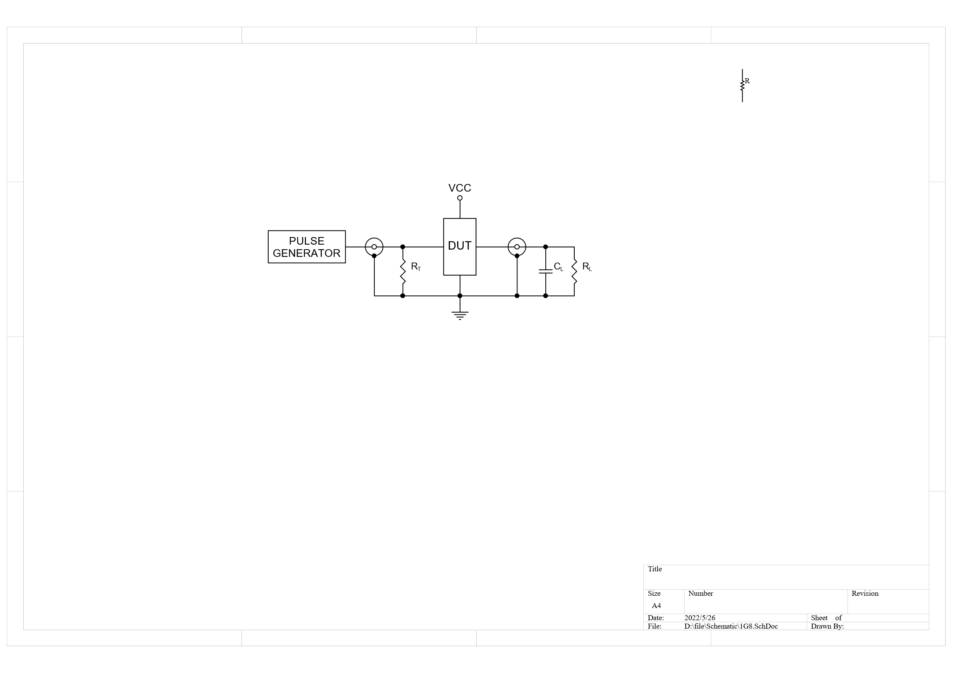

RL = Load resistance;

CL = Load capacitance including jig and probe capacitance;

RT = Termination resistance should be equal to output impedance ZO of the pulse generator.

Figure 4. Test Circuit for Measuring Switching Times

###### Package Dimension

SC70-5



Unit: mm

###### Revision History and Checking Table

|  |  |  |  |  |  |
| --- | --- | --- | --- | --- | --- |
| **Version** | **Date** | **Revision Item** | **Modifier** | **Function & Spec Checking** | **Package &**  **Tape Checking** |
| 0.0 | 2024-02-06 | Preliminary Version | Wangar | Yangxx | Liujy |
| 0.1 | 2025-05-07 | Update EC Table | Wangar | Yangxx | Liujy |