**Single Non−inverting Schmitt Trigger Buffer**

###### General Description

The ETQ74LVC1G17 is a high performance single non−inverting buffer with open drain outputs operating from a 1.65V to 5.5V supply. The Output stage is open drain with Over Voltage Tolerance.

This allows the ETQ74LVC1G17 to be used to interface 5.0V circuits to circuits of any voltage between 0V and +7.0V.

###### Features

* Designed for 1.65V to 5.5V VCC Operation
* Over-voltage Tolerant Inputs
* 24mA Balanced Output Sink and Source Capability
* Near Zero Static Supply Current Substantially Reduces System Power Requirements
* These Devices are Pb−Free and are RoHS Compliant
* MSL 1
* Automotive AEC-Q100 Grade 1 Qualified

-- Ambient temperature range of -40°C to +125°C

-- ESD HBM 4KV PASS

-- ESD CDM 1.5KV PASS

-- Latch up Current to 200mA PASS

###### Device Information

|  |  |  |
| --- | --- | --- |
| **Part No.** | **Package** | **Size** |
| ETQ74LVC1G17 | SC70-5 | 1.3mm × 2.1mm |

###### Applications

* Fully compliant with standards for automotive applications
* Combine normal power signals from multiple power rails

###### Pin Configuration



Figure 1. Top View

###### Pin Function

|  |  |  |
| --- | --- | --- |
| **Pin No.** | **Name** | **Description** |
| 1 | NC | No Connect |
| 2 | A | Input A |
| 3 | GND | Ground |
| 4 | Y | Output Y |
| 5 | VCC | Power Supply |

###### Block Diagram

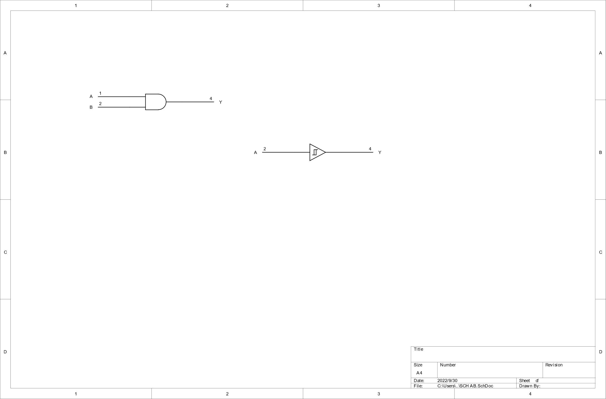

Figure 2. Logic Symbol

###### Functional Description

**Function Table**

|  |  |
| --- | --- |
| **Input A** | **Output Y** |
| L | L |
| H | H |

###### Absolute Maximum Ratings

|  |  |  |  |  |
| --- | --- | --- | --- | --- |
| **Symbol** | **Parameter** | | **Value** | **Unit** |
| VCC | DC Supply Voltage | | −0.5 to 7.0 | V |
| VI | DC Input Voltage**(1)** | | −0.5 ≤ VI ≤ +7.0 | V |
| VO | DC Output Voltage Output in Higher or Low State | | −0.5 to VCC + 0.5 | V |
| IIK | DC Input Diode Current VI < GND | | −50 | mA |
| IOK | DC Output Diode Current VO < GND, VO > VCC | | ±50 | mA |
| IO | DC Output Sink Current | | ±50 | mA |
| ICC | DC Supply Current per Supply Pin | | ±100 | mA |
| IGND | DC Ground Current per Supply Pin | | ±100 | mA |
| TSTG | Storage Temperature Range | | -65 to 150 | °C |
| TL | Lead Temperature, 1 mm from Case for 10 Seconds | | 260 | °C |
| TJ | Junction Temperature Under Bias | | 150 | °C |
| VESD | ESD Classification | Human Body Model **(2)** | ±4000 | V |
| Charged Device Model **(3)** | ±1500 |
| ILU | Latch up Current Above VCC and GND at 125°C **(4)** | | ±200 | mA |

Stresses exceeding those listed in the Maximum Ratings table may damage the device. If any of these limits are exceeded, device functionality should not be assumed, damage may occur and reliability may be affected.

***Notes:***

**1**. IO absolute maximum rating must be observed.

**2**. HBM tested per AEC-Q100-002(EIA/JESD22-A114);

**3**. CDM tested per AEC-Q100-011(EIA/JESD22-C101);

**4**. Latch up Current Maximum Rating tested per AEC-Q100-004(EIA/JESD78E).

###### Thermal Characteristics

|  |  |  |  |  |
| --- | --- | --- | --- | --- |
| **Symbol** | **Package** | **Ratings** | **Value** | **Unit** |
| RθJA | SC70-5 | Thermal Characteristics, Thermal Resistance, Junction-to-Air | 300 | °C/W |
| PD | SC70-5 | Power Dissipation  in Still Air at 85°C | 215 | mW |

###### Recommended Operating Conditions

|  |  |  |  |  |  |
| --- | --- | --- | --- | --- | --- |
| **Symbol** | **Parameter** | | **Min** | **Max** | **Unit** |
| VCC | DC Supply Voltage | | 1.65 | 5.5 | V |
| Operating Date Retention | | 1.5 | 5.5 |
| VIN | DC Input Voltage | | 0 | 5.5 | V |
| VOUT | DC Output Voltage(High or Low State) | | 0 | 5.5 | V |
| TA | Operating Temperature Range | | -40 | 125 | °C |
| tr,tf | Input Rise and Fall Time | VCC = 2.5V ± 0.2V | 0 | 20 | ns/V |
| VCC = 3.0V ± 0.3V | 0 | 10 |
| VCC = 5.0V ± 0.5V | 0 | 5 |

Functional operation above the stresses listed in the Recommended Operating Ranges is not implied.

###### Electrical Characteristics

###### DC Electrical Characteristics

|  |  |  |  |  |  |  |  |  |  |
| --- | --- | --- | --- | --- | --- | --- | --- | --- | --- |
| **Symbol** | **Parameter** | **Condition** | **VCC(V)** | **TA = 25 °C** | | | **−40°C ≤TA≤125°C** | | **Unit** |
| **Min** | **Typ** | **Max** | **Min** | **Max** |
| VIH | High−Level Input Voltage |  | 1.65-1.95 2.3-5.5 | 0.75Vcc  0.7Vcc |  |  | 0.75Vcc  0.7Vcc |  | V |
| VIL | Low−Level Input Voltage |  | 1.65-1.95 2.3-5.5 |  |  | 0.25Vcc  0.3Vcc |  | 0.25Vcc 0.3Vcc | V |
| VOH | High−Level Output Voltage  VIN = VIL | IOH = -100uA | 1.65-5.5 | Vcc−0.1 | Vcc |  | Vcc−0.1 |  | V |
| IOH = -3mA | 1.65 | 1.29 | 1.52 |  | 1.29 |  |
| IOH = -8mA | 2.3 | 1.9 | 2.1 |  | 1.9 |  |
| IOH = -12mA | 2.7 | 2.2 | 2.4 |  | 2.2 |  |
| IOH = -16mA | 3.0 | 2.4 | 2.7 |  | 2.4 |  |
| IOH = -24mA | 3.0 | 2.3 | 2.5 |  | 2.3 |  |
| IOH = -32mA | 4.5 | 3.8 | 4.0 |  | 3.8 |  |
| VOL | Low−Level Output Voltage  VIN = VIH | IOL = 100uA | 1.65-5.5 |  | 0.0 | 0.1 |  | 0.1 | V |
| IOL = 3mA | 1.65 |  | 0.08 | 0.24 |  | 0.24 |
| IOL = 8mA | 2.3 |  | 0.20 | 0.3 |  | 0.3 |
| IOL = 12mA | 2.7 |  | 0.22 | 0.4 |  | 0.4 |
| IOL = 16mA | 3.0 |  | 0.28 | 0.4 |  | 0.4 |
| IOL = 24mA | 3.0 |  | 0.38 | 0.55 |  | 0.55 |
| IOL = 32mA | 4.5 |  | 0.42 | 0.55 |  | 0.55 |
| IIN | Input Leakage Current | VIN = 5.5V  or GND | 0-5.5 |  | ±0.1 |  |  | ±1.0 | uA |

###### DC Electrical Characteristics (Continued)

|  |  |  |  |  |  |  |  |  |  |
| --- | --- | --- | --- | --- | --- | --- | --- | --- | --- |
| **Symbol** | **Parameter** | **Condition** | **VCC(V)** | **TA = 25 °C** | | | **−40°C ≤TA≤125°C** | | **Unit** |
| **Min** | **Typ** | **Max** | **Min** | **Max** |
| IOFF | Power Off Leakage Current | VIN = 5.5V  or  VOUT = 5.5V | 0 |  |  | 1 |  | 10 | uA |
| ICC | Quiescent Supply Current | VIN = 5.5V  or GND | 5.5 |  |  |  |  | 10 | uA |

Product parametric performance is indicated in the Electrical Characteristics for the listed test conditions, unless otherwise noted. Product performance may not be indicated by the Electrical Characteristics if operated under different conditions.

###### AC Electrical Characteristics

tr = tf = 5ns

|  |  |  |  |  |  |  |  |  |  |
| --- | --- | --- | --- | --- | --- | --- | --- | --- | --- |
| **Symbol** | **Parameter** | **Condition** | **VCC(V)** | **TA = 25°C** | | | **−40°C ≤TA≤125°C** | | **Unit** |
| **Min** | **Typ** | **Max** | **Min** | **Max** |
| tPLH  tPHL | Propagation Delay  (Figure3  and4) | RL= 1MΩ CL= 15pF | 1.65 | 2.0 | 12 | 16 | 2.0 | 20 | ns |
| 1.8 | 2.0 | 10.1 | 14 | 2.0 | 17 |
| RL= 1MΩ CL= 15pF | 2.5 | 0.2 | 6.2 | 9.1 | 0.8 | 11.1 |
| RL = 1MΩ CL= 15pF | 3.3 | 0.8 | 5.0 | 7.5 | 0.5 | 8 |
| RL= 500Ω CL= 50pF | 1.2 | 5.6 | 8.1 | 1.5 | 8.6 |
| RL= 1MΩ CL= 15pF | 5.0 | 0.5 | 4.4 | 5.6 | 0.5 | 6.1 |
| RL= 500Ω CL= 50pF | 0.8 | 4.8 | 6.1 | 0.8 | 6.6 |

###### Capacitance Characteristics

|  |  |  |  |  |
| --- | --- | --- | --- | --- |
| **Symbol** | **Parameter** | **Condition** | **Typ** | **Unit** |
| CIN | Input Capacitance | VCC= 5.5V, VI = 0V or VCC | >2.5 | pF |
| CPD | Power Dissipation Capacitance**(5)** | 10 MHz,VCC= 3.3V,VI = 0V or VCC | 20 | pF |
| 10 MHz,VCC= 5.5V, VI = 0V or VCC | 24 |

***Note5***. CPD is defined as the value of the internal equivalent capacitance which is calculated from the operating current consumption without load. Average operating current can be obtained by the equation: ICC(OPR)=CPD×VCC×fin+ICC×CPD is used to determine the no−load dynamic power consumption; PD=CPD×VCC2 ×fin+ICC×VCC×Fig.

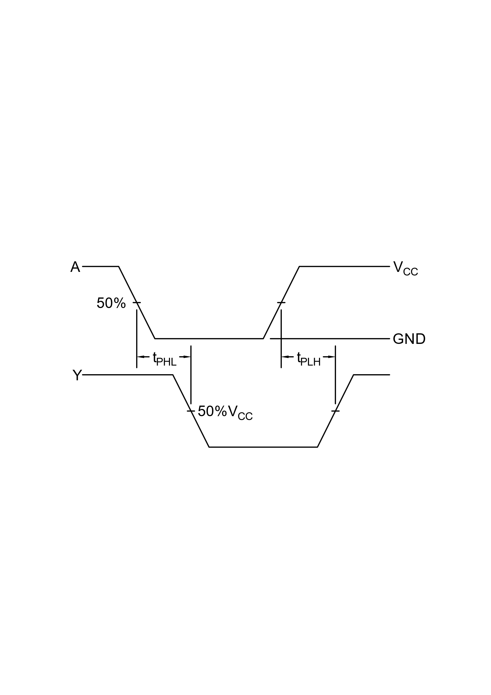 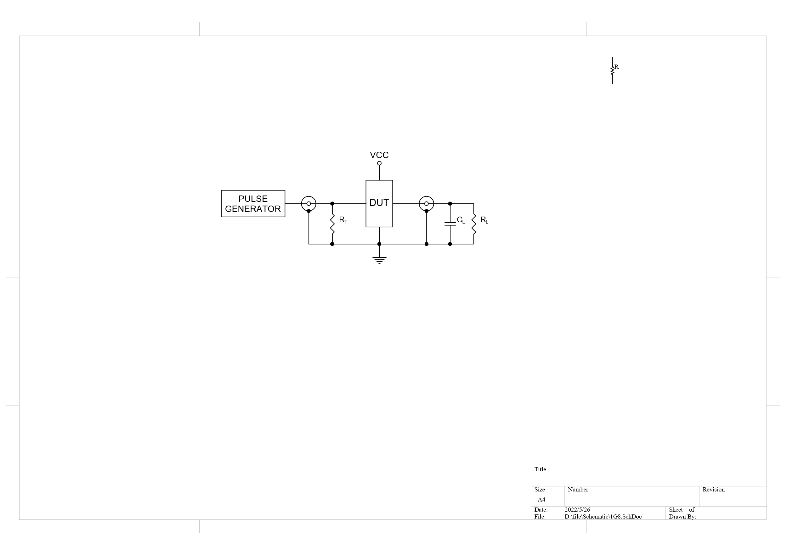

Figure 3. Switching Waveform Figure 4. Test Circuit

###### Package Dimension

SC70-5



Unit: mm

###### Revision History and Checking Table

|  |  |  |  |  |  |
| --- | --- | --- | --- | --- | --- |
| **Version** | **Date** | **Revision Item** | **Modifier** | **Function &**  **Spec Checking** | **Package &**  **Tape Checking** |
| 1.0 | 2017-10-23 | Original Version | Ma Yong jian | Ma Yong jian | Liu Jia Ying |
| 1.1 | 2022-08-01 | Update Typeset  ETQ version | Shibo | Shibo | Shibo |
| 1.2 | 2024-2-1 | Update AC Electrical Characteristics | Shibo | Shibo | Shibo |